UNIVERSITY OF NOVI SAD
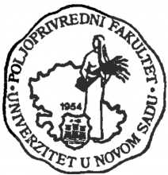
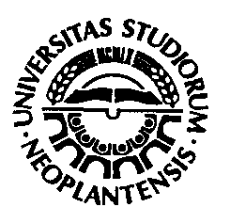
FACULTY OF AGRICULTURE

Trg Dositeja Obradovića 8, 21000 Novi Sad, Serbia
Tel. + 381 21 48 53 500; Fax. + 381 21 459 761
E-mail: dean@polj.uns.ac.rs

I n v i t a t i o n

Dear Madam or Sir,

The Faculty of Agriculture on the occasion of the Day of the Faculty traditionally organizes the Conference for Students of Agriculture. The 39th Conference will take place on the 20th of November, 2015 at the Faculty of Agriculture in Novi Sad.

The Organizing committee has a pleasure to invite two students from your University /Faculty/ to take a part in the meeting. The accommodation and board costs for those students and for one professor will be covered by the Organizing Committee.

Student’s papers can be from the following subjects: field and vegetable crops, fruit growing and viticulture, horticulture, landscape architecture, plant protection, animal husbandry, agricultural engineering, water management, agricultural economy, organic farming, and veterinary medicine.

The official languages are Serbian and English. Students who present in Serbian should have presentation in English. Simultaneous translation will not be provided.

All presented papers which fulfill the technical requirements will be published in the special publication. The best papers selected by the conference committee will be awarded.

Important dates:
Title of a paper and confirmation of attendance - November 9th, 2015
Full paper submission – November 13th, 2015

Titles, confirmation of attendance, as well as full papers should be sent to Dragana Budakov, e-mail: dbudakov@polj.uns.ac.rs

Since we are being late this year, in order to organize Conference properly, we would appreciate if you could confirm your participation and send us names of students that will represent your University /Faculty as soon as possible.

Yours faithfully,

Dean of the Faculty of Agriculture The Head of the Agricultural Students Conference
Prof. dr Nedeljko Tica Dr Dragana Budakov

