UNIVERSITY OF NOVI SAD

FACULTY OF AGRICULTURE 21000 NOVI SAD, TRG DOSITEJA OBRADOVIĆA 8
Study Programme Accreditation

MASTER ACADEMIC STUDIES IN PLANT MEDICINE
Table 9.1 Science, arts and professional qualifications
Name and last name: |  |  |  |  |  | Marija F. Zgomba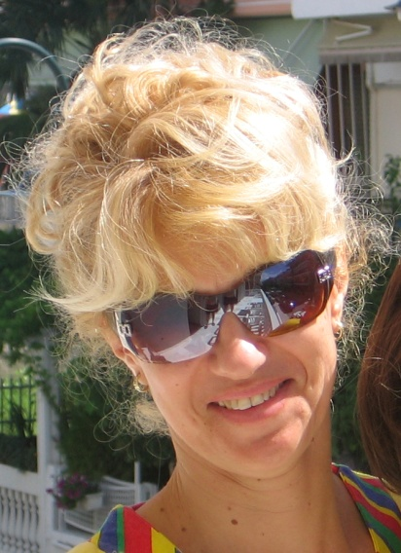
Academic title: |  |  |  |  |  | Full Professor
Name of the institution where the teacher works full time and starting date: |  |  |  |  |  | University of Novi Sad, Faculty of Agriculture  1976
Scientific or art field: |  |  |  |  |  | Phytopharmacy/Pesticide science
Academic carieer
 |  |  | Year | Institution |  |  |  |  | Field
Academic title election: |  |  | 2000 | University of Novi Sad, Faculty of Agriculture |  |  |  |  | Phytopharmacy/Pesticide Science
PhD thesis: |  |  | 1987 | University of Novi Sad, Faculty of Agriculture |  |  |  |  | Phytopharmacy/Pesticide Science
Specialization: |  |  | 1991 | EID, Montpellier, Francuska  University of California, Riverside, USA |  |  |  |  | Pesticide Science  Medical Entomology
Magister thesis |  |  | 1978 | University of Novi Sad, Faculty of Agriculture |  |  |  |  | Phytopharmacy/Pesticide science
Bachelor's thesis |  |  | 1974 | University of Novi Sad, Faculty of Agriculture |  |  |  |  | Plant Protection
List of courses being held by the teacher in the accredited study programmes
 | ID | Course name |  |  |  |  | Study programme name, study type |  |  | Number of active teaching classes
1. | 3ОFM8О34 | Zoocides |  |  |  |  | Plant Medicine; First level-undergraduate academic studies (Bachelor) |  |  | 4+0
2. | 3ОFM7I53 | Control of Synantrophic insects |  |  |  |  | Plant Medicine; First level-undergraduate academic studies (Bachelor) |  |  | 2+0
3. | 3МFМ1О05 | Applied Phytopharmacy |  |  |  |  | Plant Medicine; Second level-graduate academic studies (Master) |  |  | 0.67+0
4. | 3ОАG7О31 | Pesticides 2 |  |  |  |  | Agroecology and Environmental Protection; First level- undergraduate academic studies (Bachelor) |  |  | 1+0
5. | 3ОАG7О35 | Integrated Pest Management |  |  |  |  | Agroecology and Environmental Protection; First level-undergraduate academic studies (Bachelor) |  |  | 2+0
6. | 3OAE2010 | Basics of Plant Protection |  |  |  |  | Agroeconomy; First level-undergraduate academic studies (Bachelor) |  |  | 2+0
7. | 3ORT3O14 | Plant protection |  |  |  |  | Technicques in Agriculture; First level-undergraduate academic studies (Bachelor) |  |  | 2+0
8. | 7ОAТ6I08 | Ecological Basis of Plant and Environmental Protection |  |  |  |  | Agrotourism and rural development; First level-undergraduate academic studies (Bachelor) |  |  | 2+0
9. | 3DAI2059 | Advanced Phytopharmacy 2 |  |  |  |  | Agronomy; Third level- Doctoral studies (PhD) |  |  | 1.5+0
10 | 3МGB1I30 | Integrated pest managment in vegetables |  |  |  |  | Field Plant Growing; Second level -graduate academic studies (Master) |  |  | 2+2
Representative refferences (minimum 5, not more than 10)
 | Petrić, D., Zgomba, M., Bellini, R. and Becker N. (2012): Surveillance of Mosquito Populations: A Key Element to Understanding the Spread of Invasive Vector Species and Vector-Borne Diseases in Europe. In D. Mihailović Ed.: Essays on Fundamental and Applied Environmental Topics. Nova Science Publishers. p. 192-224.
 | Becker N., Petrić D., Zgomba M., Boase C., Madon M., Dahl C. and Kaiser A. (2010): Mosquitoes and their control. Second Edition. Springer Verlag, Heidelberg ISBN 978-3-540-92873-7. pp579
 | Becker N. and Zgomba M.(2007): Mosquito control in Europe. In: Emerging pests and vector-borne diseases in Europe edited by Willem Takken and Bart G. J. Knols. Volume 1. Wageningen Academic Publishers. ISBN 978-90-8686-053-1. ISSN 1875-0699. pp. 499.
 | Becker N., Petrić D., Zgomba M, Boase C., Dahl C, Lane J. and Kaiser A.. (2003). Mosquitoes and their control. Kluwer Academic/Plenum Publishers, New York. ISBN 0-306-47360-7. pp.498.
 | Zgomba M., Petrić D. (2008): Risk Assessment and Management of Mosquito-Born Diseases in the European Region. Proceedings of the 6th International Conference on Urban Pest. Editors William H. Robinson and Daniel Bajomi.pp 29-39. ISBN 978-963-06-5326-8
Summary data for the teacher's scientific or art and professional activity:
Quotation total: |  |  |  |  | 52
Total of SCI (SSCI) list papers: |  |  |  |  | 6
Current projects: |  |  |  |  | Domestic: 2 |  |  | International:
Specialization |  | Switzerland, France, United States, Greece, Germany

