 | UNIVERSITY OF NOVI SAD  FACULTY OF AGRICULTURE 21000 NOVI SAD, TRG DOSITEJA OBRADOVIĆA 8 | 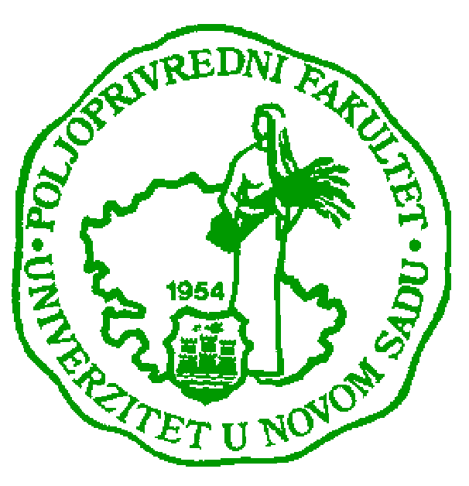
Study Programme Accreditation

MASTER ACADEMIC STUDIES ANIMAL SCIENCE
Table 9.1 Science, arts and professional qualifications
Name and last name: |  |  |  |  |  |  |  | Denis S. KUČEVIĆ
Academic title: |  |  |  |  |  |  |  | Assistant Professor
Name of the institution where the teacher works full time and starting date: |  |  |  |  |  |  |  | Faculty of Agriculture, Novi Sad, 15.01.2008.
Scientific or art field: |  |  |  |  |  |  |  | Animal Science
Academic carieer
 |  |  |  |  | Year | Institution |  |  |  |  | Field
Academic title election: |  |  |  |  | 2011 | Faculty of Agriculture, Novi Sad, 15.01.2008. |  |  |  |  | Animal Science
PhD thesis: |  |  |  |  | 2009 | Justus Liebig University, Giessen, Germany |  |  |  |  | Animal Science
Specialization: |  |  |  |  | -
Magister thesis |  |  |  |  | 2004 | Anhalt University of Applied Sciences, Bernburg, Germany |  |  |  |  | Food and Agribussines, Animal Science
Bachelor's thesis |  |  |  |  | 2000 | Faculty of Agriculture, Belgrade, Serbia |  |  |  |  | Animal Science
List of courses being held by the teacher in the accredited study programmes
 |  | ID |  | Course name |  |  |  |  | Study programme name, study type |  |  | Number of active teaching classes
1. |  | 3ОСТ7О29 |  | Cattle management |  |  |  |  | Animal Science, Undergraduate academic studies |  |  | 2+0
2. |  | 3ОАЕ2О08 |  | Livestock production and nutrition |  |  |  |  | Agricultural Economics, Undergraduate academic studies |  |  | 0+4
3. |  | 7ОАТ3О15 |  | Livestock Production |  |  |  |  | Agritourism and Rural Development, Undergraduate academic studies |  |  | 0+2
4. |  | 3ООП6О28 |  | Ruminants breeding in organic farming |  |  |  |  | Organic Agriculture, Undergraduate academic studies |  |  | 0+1
5. |  | 3МСТ1И03 |  | System of cattle hosing and farm management |  |  |  |  | Animal Science, Master Studies |  |  | 1+0
Representative refferences (minimum 5, not more than 10)
 | D. Kucevic, Martin Wähner, Steffen Hoy: Soziometrische Untersuchungen in Milchkuh-Herden unter Berücksichtigung der Eingliederung der Tiere. Züchtungskunde, 82, (6) S. 428–436, 2010.
 | S. Stankovski, G. Ostojic, I. Senk, M Rakic-Skokovic, S. Trivunovic, D. Kucevic. Dairy cow monitoring by RFID. Scientia Agricola. v.69, n.1, p.75-80, Jan/Feb 2012
 | S. Trivunović, D. kuĉević, S. Matić-Kekić, N. Dedović: Einfluss von Fortpflanzung und Selektion auf die Anzahl an Kühen und Kälbern in Milkvieh -und Mutterkuhherden, 93-96, ISSN 1437-3807 35/36, 2011
 | D. kuĉević, S. Trivunović, M. Radinović, M.Plavšić, Z. Skalicki, P. Perišić: The effect of the farm size on milk traits of cows, Biotechnology in Animal Husbandry, v.27, 3, 951-958, 2011
 | V. Bogdanovć, R. Ðedović, P. Perišić, D. Stanojević, M.D. Petrović, S. Trivunović, D. Kuĉević, M. M. Petrović: Аn assessment of dairy farm structure and characteristics of dairy production systems in Serbia, Biotechnology in Animal Husbandry, Vol. 28, 4, 689-697, 2012
 | S. Trivunović, D. Ivanović, D. Kuĉević, V.Pantelić, J. Korora, M.Radinović: Genetic parametters of incidence of dytsocia and number of stillbirths in population of Holstein-Friesian cows in Vojvodina, Biotechnology in Animal Husbandry, v. 27, 3, 1051-1058, 2011
 | Kuĉević, D., Waehner M., Petrović M.M., Pantelić V., (2005): Ispitivanje vaţnijih tovnih osobina muških meleza F1 generacije Nemaĉke fleckvieh rase sa domaćom simentalskom rasom. Biotechnology in Animal Husbandry, 3-4 (21) str. 43- 48.
 | Kuĉević, Denis, Waehner Martin., Petrović, M. Milan, Pantelić Vlada: Investigation of milk traits of same Simmental bulls' daughters in Germany and Serbia. Biotechnology in Animal Husbandry, 21 (1-2), 21-27, 2005.
Summary data for the teacher's scientific or art and professional activity:
Quotation total: |  |  |  |  |  |  | 5
Total of SCI (SSCI) list papers: |  |  |  |  |  |  | 2
Current projects: |  |  |  |  |  |  | Domestic: 3 |  |  | International:1
Specialization |  |  | In 2006: 10 months of study stay in the research center Eichof, Germany and 3 months at Anhalt University of Applied Sciences, Bernburg, Germany

