 | UNIVERSITY OF NOVI SAD  FACULTY OF AGRICULTURE 21000 NOVI SAD, TRG DOSITEJA OBRADOVIĆA 8 | 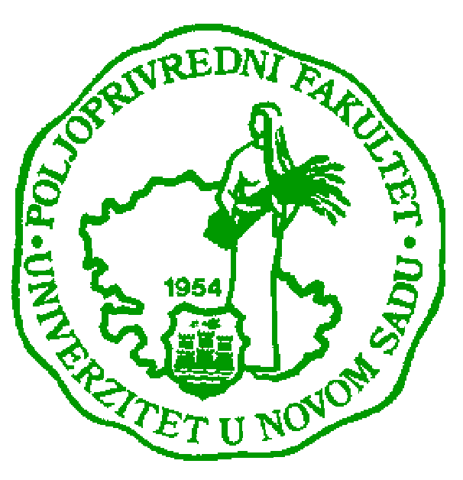
Study Programme Accreditation

MASTER ACADEMIC STUDIES (uneti naziv programa)
Table 9.1 Science, arts and professional qualifications
Name and last name: |  |  |  |  |  |  |  | Jasmina V. Josimov-Dundjerski
Academic title: |  |  |  |  |  |  |  | Assistant Professor
Name of the institution where the teacher works full time and starting date: |  |  |  |  |  |  |  | University of Novi Sad Faculty of Agriculture, Novi Sad  5th January 1987.
Scientific or art field: |  |  |  |  |  |  |  | Water Management
Academic carieer
 |  |  |  |  | Year | Institution |  |  |  |  | Field
Academic title election: |  |  |  |  | 2011 | University of Novi Sad  Faculty of Agriculture |  |  |  |  | Water Management
PhD thesis: |  |  |  |  | 2010 | University of Novi Sad  Faculty of Agriculture |  |  |  |  | Water Management
Specialization:
Magister thesis |  |  |  |  | 1990 | University of Novi Sad  Faculty of Agriculture |  |  |  |  | Hydrology
Bachelor's thesis |  |  |  |  | 1986 | University of Novi Sad  Faculty of Agriculture |  |  |  |  | Water Management
List of courses being held by the teacher in the accredited study programmes
 |  | ID | Course name |  |  |  |  |  | Study programme name, study type |  |  | Number of active teaching classes
1. |  |  | Water Supply |  |  |  |  |  | Water Management - Basic |  |  | 3+2
2. |  |  | Introduction to Hydrology |  |  |  |  |  | Water Management - Basic |  |  | 0+2
3. |  |  | Engineering Hydrology |  |  |  |  |  | Water Management - Basic |  |  | 0+4
4. |  |  | Constructed Wetland Systems |  |  |  |  |  | Water Management - Basic |  |  | 2+2
5. |  |  | Analysis of Influence to Environmental |  |  |  |  |  | Water Management - Master |  |  | 1+1
6. |  |  | Self - purification of Water Course |  |  |  |  |  | Water Management – Master |  |  | 1+1
7. |  |  | Constructed Wetlands in Protection of Water Resources |  |  |  |  |  | Sustainability in Agriculture, Food Production and Food Technology in the Danube Region - Master |  |  | 1+1
Representative references (minimum 5, not more than 10)
 | Jasmina Josimov-Dundjerski, Radovan Savić, Andjelka Belić, Atila Salvai and Jasna Grabić. (2014). Sustainability of constructed wetland based on the characteristics in effluent. Soil and Water Research. 133/2014-SWR in press.
 | Radovan Savic, Gabrijel Ondrasek and Jasmina Josimov-Dundjerski. (2013). Heavy metals in agricultural landscapes as hazards to human and ecosystem health - a case study on zinc and cadmium in drainage channel sediments. Journal of the Science of Food and Agriculture. DOI: 10.1002/jsfa.6515
 | Jasmina Josimov-Dundjerski, Andjelka Belic, Atila Salvai and Jasna Grabic. (2013). Age of constructed wetland and effects of wastewater treatment. Bulgarian Journal of Agricultural Science, 19: 684-689.
 | Jasmina Josimov-Dundjerski, Anđelka Belić, Mirjana Jarak, Ljiljana Nikolić, Milica Rajić and Atila Bezdan. (2012). Constructed Wetland – the Serbian Experience. Carpathian Journal of Earth and Environmental Sciences, 7(2): 101-110.
 | Jasmina Josimov-Dundjerski, Ljiljana Nikolić, Anđelka Belić, Slobodanka Stojanović and Atila Bezdan. (2011). Nutrient Levels in a Constructed Wetland System Gložan (Vojvodina Province). Bulgarian Journal of Agricultural Science, 17: 31-39.
Summary data for the teacher's scientific or art and professional activity:
Quotation total: |  |  |  |  |  |  | 15
Total of SCI (SSCI) list papers: |  |  |  |  |  |  | 5
Current projects: |  |  |  |  |  |  | Domestic: |  |  | International:
Specialization

