Course: |  | SELF PURIFICATION IN STREAM WATERS
Course id: 7MUV9I06
Number of ECTS: 6
Teacher: |  | Ph.D., Anđelka Belić (Teacher), Ph.D. Jasmina Josimov-Dunđerski (Assistant)
Course status |  | Elective
Number of active teaching classes (weekly)
Lectures: 30 |  | Practical classes: 30 |  |  | Other teaching types: |  | Study research work: |  | Other classes:
Precondition courses |  | None
- Educational goal
The aim of the course is to provide students the knowledge of the elements of self-purification of watercourses, oxygen regime as the holder of self purification and opportunities for application of the existing mathematical models.
- Educational outcomes
Students will acquire the necessary knowledge of the self-purification of watercourses, overcoming the elements of the process, the elements that affect its change, requests for the application of existing models in order to forecast future states of the quality of watercourses.
- Course content
Theory lessons:
- The phenomenon of self-purification in watercourses
- Process of self purification
- The balance of oxygen in the watercourses: reaeration, determine the coefficient reaeration and functional dependencies
- Oxidation and deoxygenation: oxidation of organic carbon, nitrogen oxidation forms, specifics deoxygenation in the rivers, the coefficient of oxidation, deoxygenation coefficient, coefficient of reduction of organic matter in the water, the ratio of nitrification
- Primary production
- Mathematical interpretation
Practical classes:
- Calculation of self- purification on selected stretches of watercourses
- Teaching methods
Lectures, presentations generated by computer.
Knowledge evaluation (maximum 100 points)
Pre-examination obligations |  |  | Mandatory | Points |  | Final exam |  | Mandatory |  | Points
Lecture attendance |  |  | Yes | 10 |  | Oral part of the exam |  | Yes |  | 50
Test |  |  | Yes | 10
Exercise attendance |  |  | Yes | -
Term paper |  |  | Yes | 30
Literature
Ord. | Author |  | Title |  |  | Publisher |  |  |  | Year
 | van Gils J. Lecture notes, |  | Water Quality Modeling |  |  | UNESCO-IHE, Delft. |  |  |  | 2004
 | Veselinović D. i saradnici |  | Stanja i procesi u životnoj sredini |  |  | Fakultet za fizičku hemiju, Beograd. |  |  |  | 1995.
 | Čukić Z. |  | Procesi u vodoprijemnicima |  |  | Univerzitet u Novom Sadu, Tempus centar. |  |  |  | 1995.
 | UNIVERSITY OF NOVI SAD  FACULTY OF AGRICULTURE 21000 NOVI SAD, TRG DOSITEJA OBRADOVIĆA 8 | 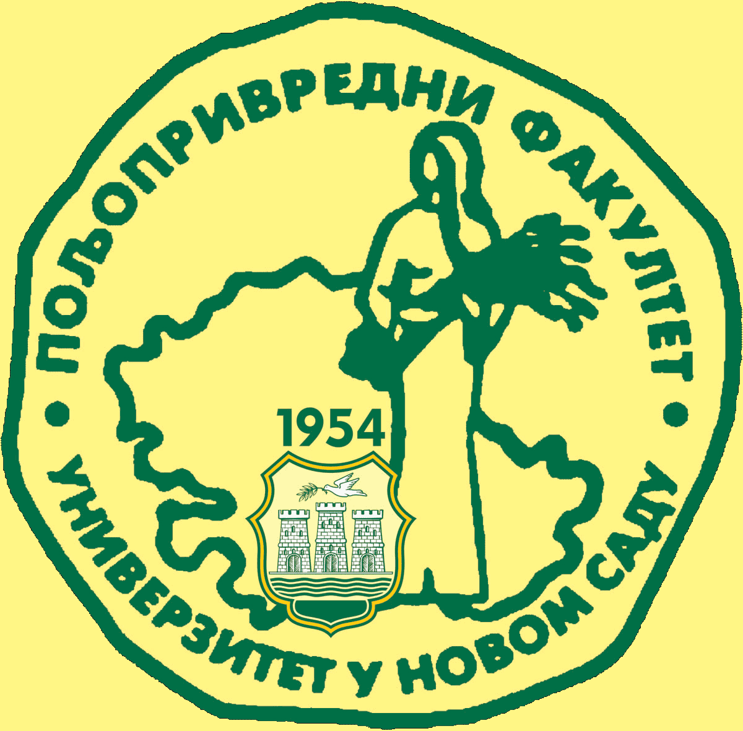
Study Programme Accreditation

MASTER ACADEMIC STUDIES WATER MANAGEMENT
Table 5.2 Course specification

