Course: |  | GROWING FISH
Course id: 3МST1I20
Number of ECTS: 6
Teacher: |  | Nada P. Plavsa, Jelena B. Stanivuk
Course status |  | Elective
Number of active teaching classes (weekly)
Lectures:  15x2 = 30 |  | Practical classes:  15x2 =20 |  |  | Other teaching types: |  | Study research work: |  |  | Other classes:
Precondition courses |  | Fish production
- Educational goal

The introduction of modern technologies of cultivation and treatment in the fishing production in order to achieve better economic effects and quality of fish meat.

- Educational outcomes

Acquired knowledge of the student provide expertise in obtaining fish meat as safe and very quality foods in the diet of the population.

- Course content

Theory lessons

Introduction to the subject; The water quality for fish breeding; Morphological and physiological characteristics the most important fish species; Anatomy and physiology of fish; Location and construction of carp ponds; Growing fish in carp ponds; Modern aspects of selection of fish; Selecting and growing brood stock; Growing technology warm water fish; Modern methods of growing fish in
salmon trout ponds; Special forms of breeding fish; Health problems in cultivation of fish; Fish farming in the thermal waters and aquarium; Meat quality of fish in terms of protection consumer health; Fish processing.

Practical teaching:

Building a pond; Technological process of fish; Measurement of basic physical and chemical water parameters; The measurement of the number and amount of basic living communities in water; Levels of of pathogens of fish.

- Teaching methods

Oral presentation, pp-presentations, work on farms, laboratory work, consultations

Knowledge evaluation (maximum 100 points)
Pre-examination obligations |  |  | Mandatory | Points |  | Final exam |  |  | Mandatory |  | Points
Lecture attendance |  |  | Yes | 5 |  | Written part of the exam- theory |  |  | Yes |  | 15
Test |  |  | Yes | 5 |  | Oral part of the exam |  |  | Yes |  | 25
Exercise attendance |  |  | Yes | 40
Term paper |  |  | Yes | 10
Literature
Ord. | Author |  |  |  | Title |  |  | Publisher |  |  | Year
 | Bogut I. i sar. |  |  |  | Biologija riba |  |  | Poljoprivredni fakultet Osijek |  |  | 1996.
 | Fijan N. |  |  |  | Zaštita zdravlja riba |  |  | Poljoprivredni fakultet Osijek |  |  | 2006.
 | Bogut, I., Horvath, L., Adamek, Z., Katavić, I. |  |  |  | Ribogojstvo |  |  | Poljoprivredni fakultet Osijek |  |  | 2006.
 | UNIVERSITY OF NOVI SAD  FACULTY OF AGRICULTURE 21000 NOVI SAD, TRG DOSITEJA OBRADOVIĆA 8 | 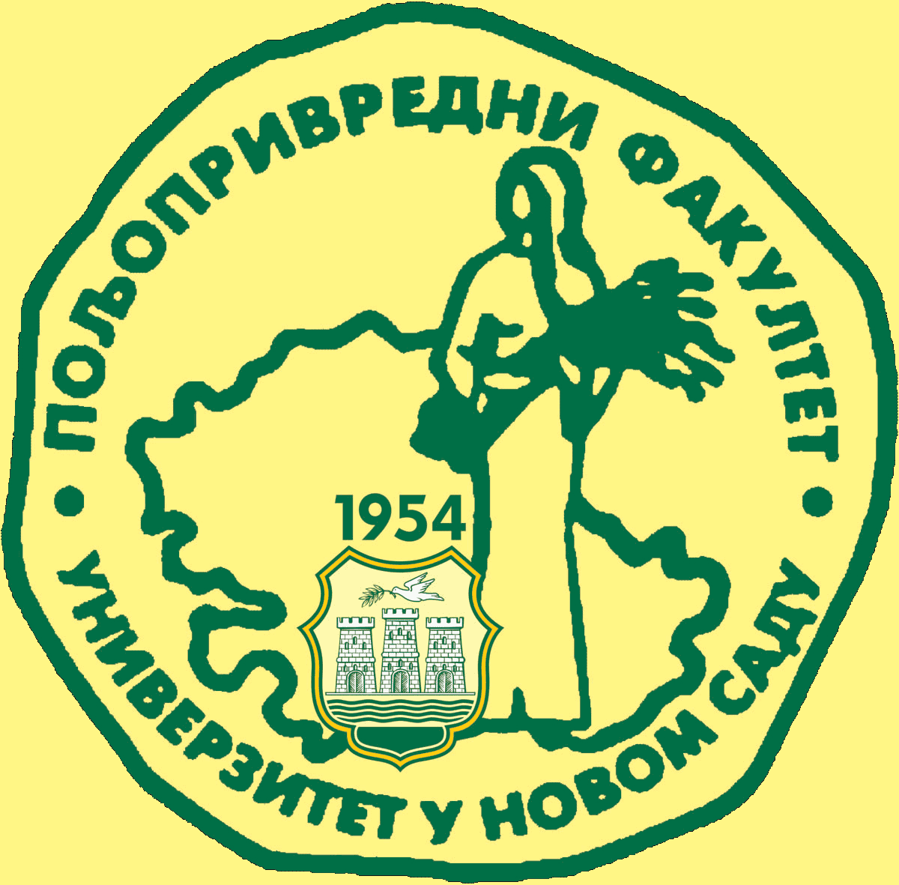
Study Programme Accreditation

MASTER ACADEMIC STUDIES Animal Production
Table 5.2 Course specification

