Course: |  | master thesis
Course id: 3МFM2О07
Number of ECTS: 20
Teachers: |  | Any professor involved in teaching process at Master studies in Plant Medicine can be a Mentor, depending on student choice
Course status |  | Mandatory
Number of active teaching classes (weekly)
Lectures: |  | Practical classes: |  |  | Other teaching types: |  | Study research work:10x15=150 |  | Other classes:
Precondition courses |  | fulfilled exam in the subject Тheoretical and experimental basics of the master thesis
- Educational goal
Independent application of specific methods, equipment and techniques of experimental work in the laboratory and/or field. Independent data processing, acquiring and use of literature (scientific publications), writing and interpretation of obtained work results
- Educational outcomes
The student acquires the basis for independent writing of scientific publication and further continuation of education at doctoral (PhD) studies
- Course content
The Master thesis has to contain the usual chapters: Introduction, Work hypothesis, Review of literature, Material and methods, Research results and discussion, Conclusions, Literature
- Teaching methods
Experimental performance of field and laboratory trials, in accordance with adequate statistical methods, coordinated by the mentor
Knowledge evaluation (maximum 100 points)
Pre-examination obligations |  |  | Mandatory | Points |  | Final exam |  | Mandatory |  | Points
Lecture attendance |  |  | No |  |  | Master thesis defense |  | Yes |  | 100
Test |  |  | No
Exercise attendance |  |  | No
Literature
Ord. | Author |  | Title |  |  | Publisher |  |  |  | Year
 | UNIVERSITY OF NOVI SAD  FACULTY OF AGRICULTURE 21000 NOVI SAD, TRG DOSITEJA OBRADOVIĆA 8 | 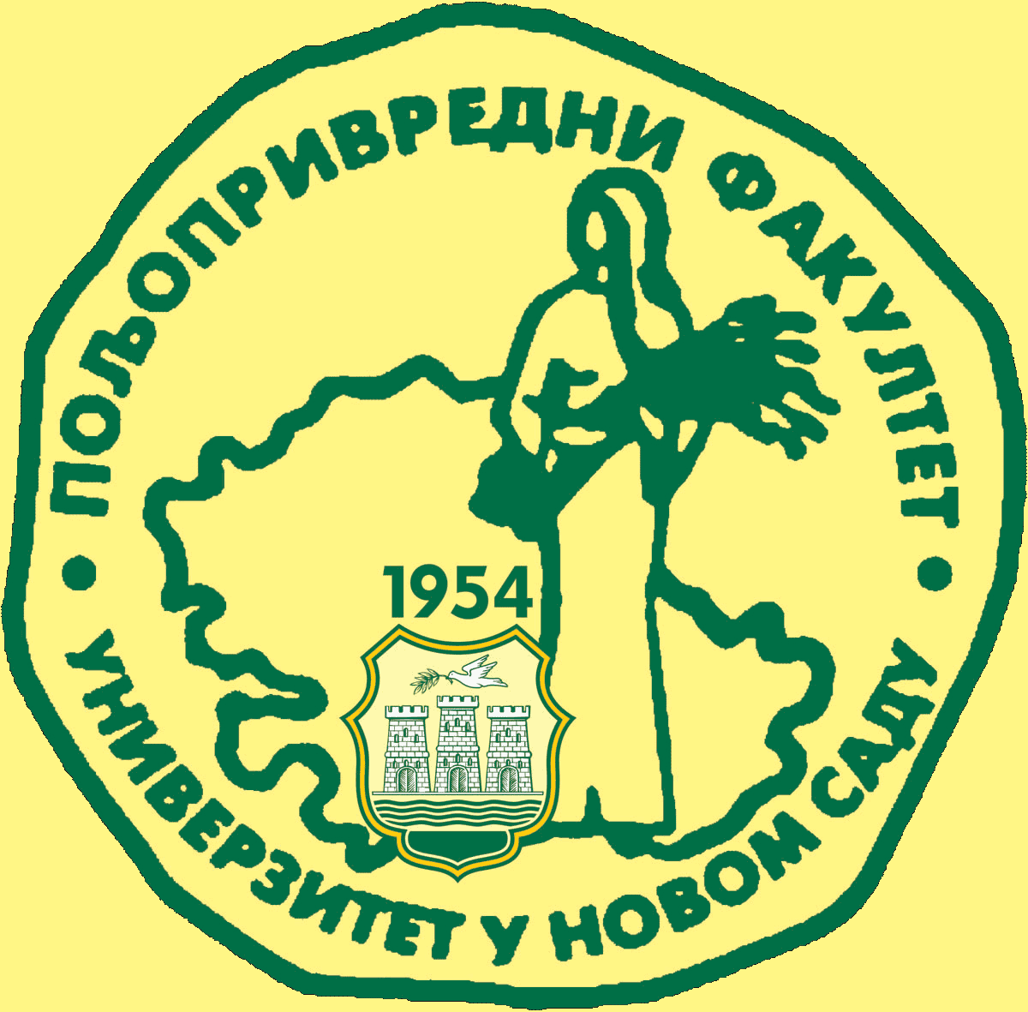
Study Programme Accreditation

MASTER ACADEMIC STUDIES IN PLANT MEDICINE
Table 5.2 Course specification

