Course: |  | Organic livestock production
Course id: |  | 3МОП1И11
Number of ECTS: |  | 6
Teacher: |  | Prof.dr Lidija V. Perić; Asst.prof. Mirjana B.Đukić Stojčić
Course status |  | Elective
Number of active teaching classes (weekly)
Lectures: 30 |  | Practical classes:30 |  |  | Other teaching types: |  | Study research work: |  | Other classes:
Precondition courses |  | None
- Educational goal
Education and training of students for professional and scientific work in the field of organic livestock production.
- Educational outcomes
The expert who has broadened and deepened knowledge in the field of organic livestock production and who has the expertise to work on farms, in research centers, institutes and colleges in dealing with organic livestock production.
- Course content
Theory lessons
Basic principles in conventional livestock production - a way of keeping the welfare of farm animals; Basic Principles in organic livestock production;
The current state of organic livestock production in Serbia; Organic pig production; Organic beef production - fattening; Organic beef production - milk production;
Organic sheep and goat production; Organic poultry production; Product quality and the possibility of placements; Effects of organic livestock production on the environment and appropriate legislation.
Practical teaching: Exercise,
Comparison of feed and feeding of domestic animals in conventional and organic production; Comparing the quantity and quality of the products obtained in conventional and organic production; Comparison of success in reproduction by DZ in conventional and organic production; Analysis of the impact of organic farming on the welfare and health of domestic animals;
- Teaching methods
Lectures, and Practical classes, field Exercise
Knowledge evaluation (maximum 100 points)
Pre-examination obligations |  |  | Mandatory | Points |  | Final exam (izabrati) |  | Mandatory |  | Points
Lecture attendance |  |  | Yes | 5 |  | Oral part of the exam |  | Yes |  | 20
Test |  |  | Yes | 50
Exercise attendance |  |  | Yes | 5
Term paper |  |  | Yes | 20
Literature
Ord. | Author |  | Title |  |  | Publisher |  |  |  | Year
 | Петровић Милица |  | Сточарство |  |  | Поljoprivredni fakultet, Beograd, |  |  |  | 2000
 | Mirecki Nataša; Wehinger, T.; Jaklič, M. |  | Priručnik za organsku proizvodnju. |  |  | Biotehnički fakultet Podgorica |  |  |  | 2011
 | UNIVERSITY OF NOVI SAD  FACULTY OF AGRICULTURE 21000 NOVI SAD, TRG DOSITEJA OBRADOVIĆA 8 | 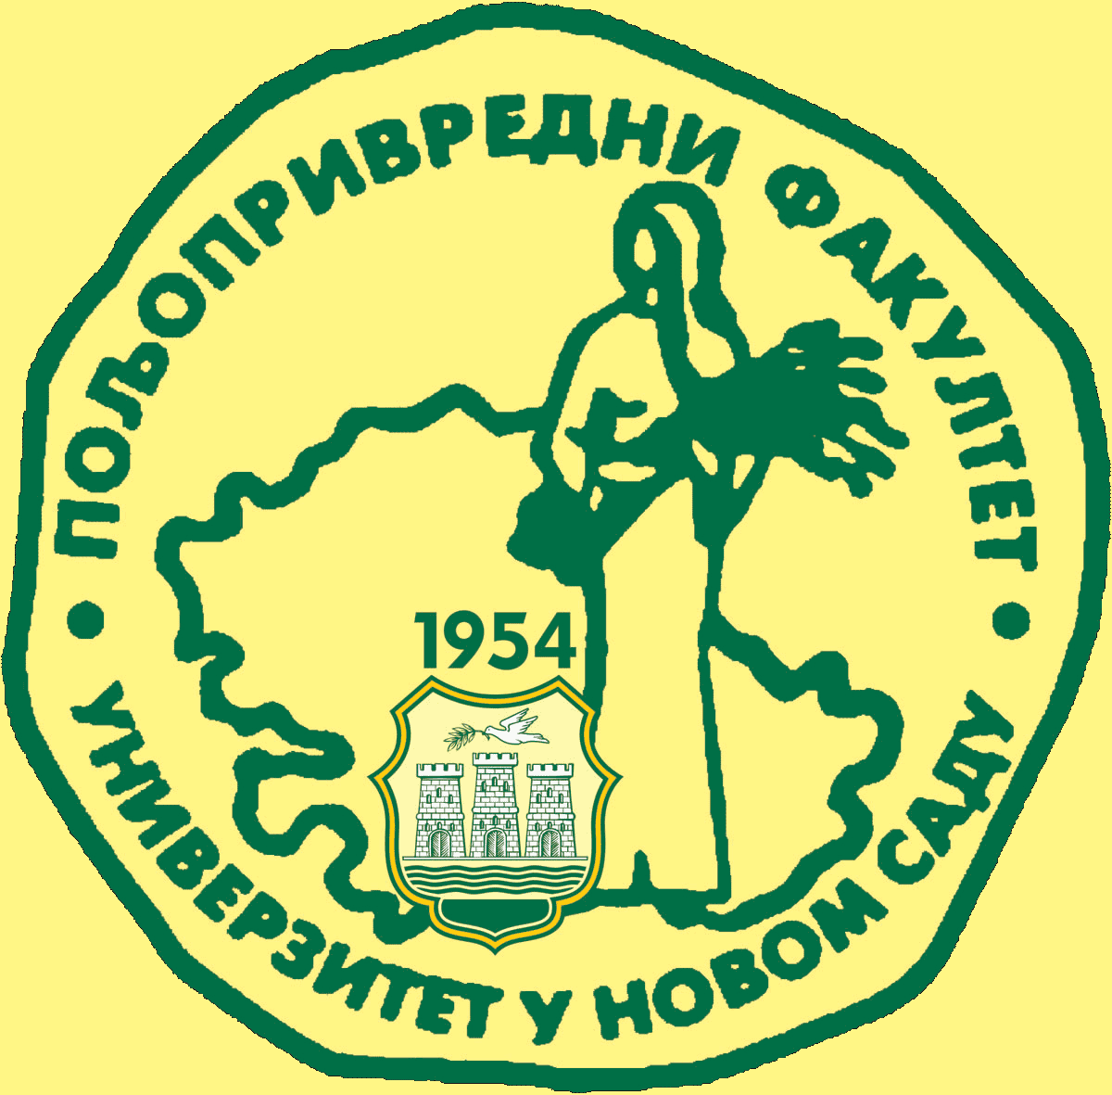
Study Programme Accreditation

MASTER ACADEMIC STUDIES ORGANIC AGRICULTURE
Table 5.2 Course specification

