Why Study Organic Agriculture?

The ever increasing demand for products made by the application of organic agriculture methods requires new scientific findings on sustainable systems of organic production. Simultaneously, reports on negative effects of intensive agricultural production on water and soil quality, biodiversity and animal welfare have caused public concern about the ways in which food is produced.
Organic agriculture represents a production system which is able to meet the requirements of society so that its final product is quality and safe healthy food. This process is followed by the conservation and renewal of natural resources, as well as the return to traditional values and expertise in agricultural production.
Completing the Organic Agriculture Study Programme, our students gain a bachelor’s degree in organic agriculture, becoming competent on national, European and world scales, respectively. They also become trained for primary and secondary organic production or for further education and professional specialization.
The significance of the Organic Agriculture Study Programme lies in the fact that organic production is taking an important position in the Serbian national programme, especially in the Autonomous Province of Vojvodina. Therefore, the purpose of this study programme is to train highly skilled experts in rational and sustainable plant and animal production.
Completing the Organic Agriculture Study Programme, students gain necessary knowledge which they can apply in practice or in their further scientific and research work.

Principal Objectives of the Study Programme

Since the key idea of organic production is based on the thesis that exploitation should be adjusted to natural conditions and that soil recovery should be provided, the aim of the Organic Agriculture Study Programme is that students master the methods which are to enable them to produce quality and safe food. Simultaneously, the negative effects of intensive agricultural production on ecosystems should be diminished.
Student are trained to become competent in highly expert direct work in organic production, i.e., to apply professionally modern and efficient technologies in production circumstances. Future experts are educated to actively and efficiently follow all contemporary findings in the field of organic agriculture. Also, they become able to develop and improve the efficiency of such production in practice.
The Programme’s special aim is the idea of developing different levels of knowledge and raising students’ awareness about the necessity of permanent education, especially in the context of sustainable development.

Employment Possibilities upon Completion of the Study Programme

- Businesses dealing with or related to agriculture
- Government and administration bodies; local government (agricultural agencies, agricultural extension services etc.)
- Education
- Laboratories at faculties and institutes
- Banks and other businesses

Possibilities for Further Education

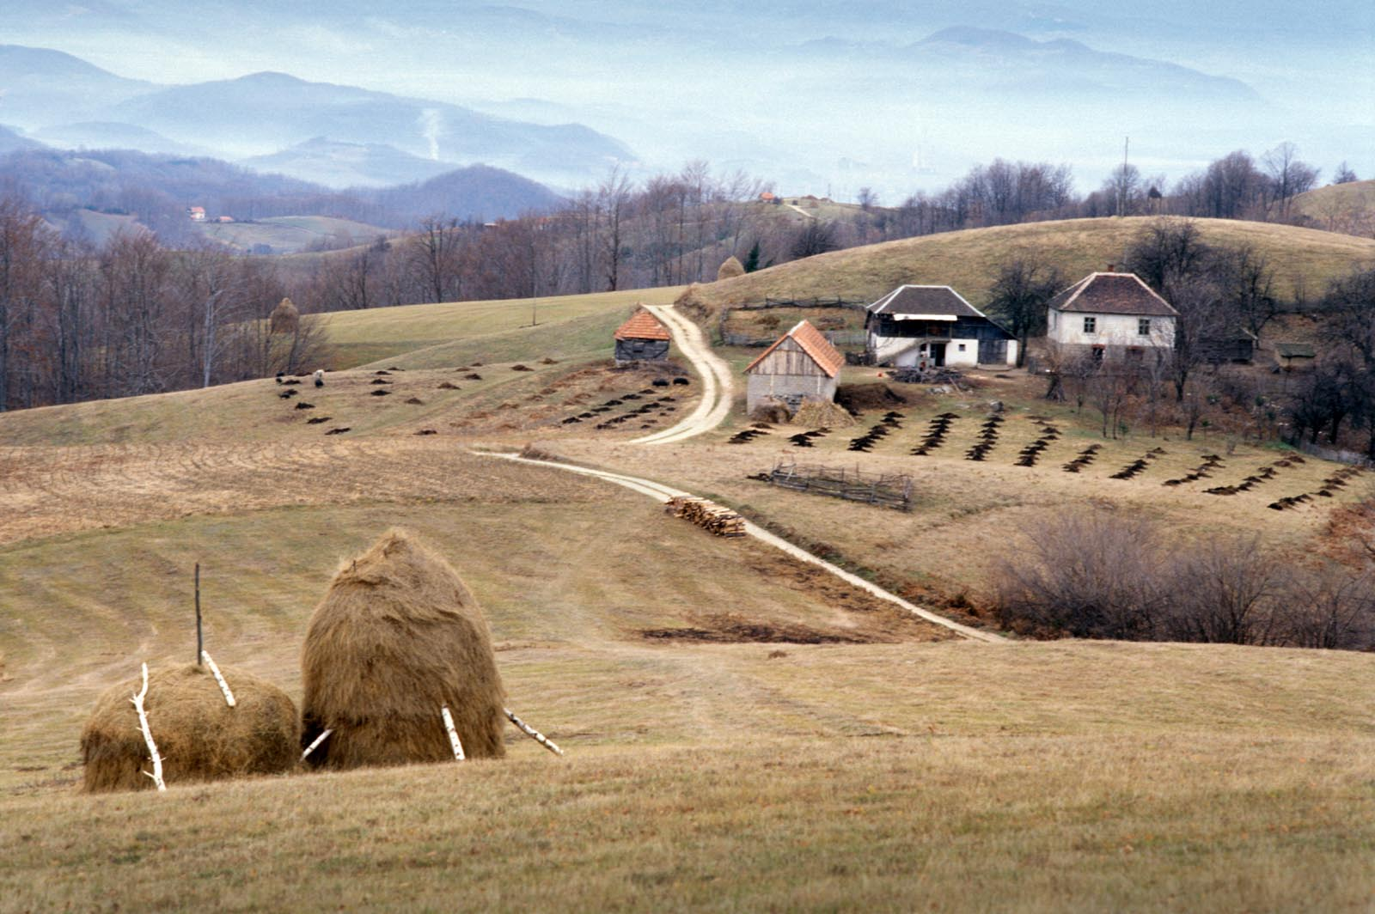
Bachelors of Science in organic agriculture are competent to further their education by pursuing master and doctoral studies within the related fields of science.

