 | UNIVERSITY OF NOVI SAD  FACULTY OF AGRICULTURE 21000 NOVI SAD, TRG DOSITEJA OBRADOVIĆA 8 | 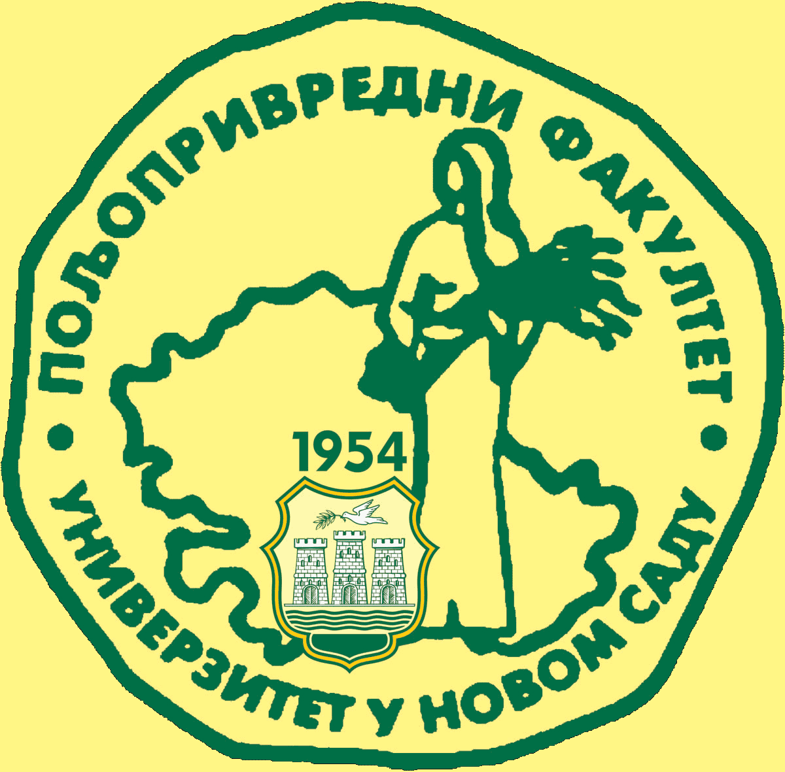
Study Programme Accreditation

UNDERGRADUATE ACADEMIC STUDIES
AGRICULTURAL TOURISM AND RURAL DEVELOPMENT
Table 5.2 Course specification
Course: |  | English Language II
Course id: 7ОАТ2О10
Number of ECTS: 5
Teacher: |  | Bojana B. Komaromi, Aleksandar M. Jagrović, Igor Đ. Cvijanović
Course status |  | Mandatory
Number of active teaching classes (weekly)
Lectures: 2 |  | Tutorials: 2 |  |  | Other teaching types: |  | Study research work: |  | Other classes:
Precondition courses |  | None
1.Educational goals
Enhancing and perfecting basic patterns of grammar, pronunciation, spoken and written language in order to improve students’ ability to communicate in General English. Revision, improvement and activation of basic specialist terms and concepts in the field of agritourism, tourism, business and management.
2.Educational outcomes
Students will be capable of active usage of General English at the pre-intermediate level (A2 level according to Common European Framework of Reference for Languages). Students will also be able to actively use basic specialist terms and concepts in the field of agricultural tourism, tourism, business and management.
3.Course content
Theoretical instruction
Phonetics: Correction of students’ pronunciation, accent and intonation according to one of the standard dialects of the English language (British and/or American). Morphology: Nouns – plural, gender, genitive. Pronouns – personal, possessive, question, relative and reflexive. Adjectives – formation and comparison. Adverbs – Formation, place and comparison. Verbs – Forms, auxiliaries, modal verbs, tenses, gerund. Syntax: Word order, clauses, sentences, sentence organisation. Lexical forms – phrasal verbs, idioms, collocations and compounds. Translation – Bilingual translation: from Serbian into English and vice versa.
Practical instruction
Spoken language practice in everyday situations. Development of translation skills and techniques. Grammar activation and revision via exercises. Delivering specialist presentations in the field of agritourism, tourism, business and management in English.
4.Teaching methods
Lectures, tutorials, consultations. Working in small groups and pairs. Individual work with audio-visual equipment.
Knowledge evaluation (maximum 100 points)
Pre-examination obligations |  |  | Mandatory | Points |  | Final exam |  | Mandatory |  | Points
Lecture attendance |  |  | Yes/No | 10 |  | Written exam |  | Yes/No |  | 20
 |  |  |  |  |  | Oral exam |  | Yes/No |  | 30
Tests |  |  | Yes/No | 15+15
Practical work |  |  | Yes/No | 10
Seminars |  |  | Yes/No | -
Literature
Ord. | Author |  | Title |  |  | Publisher |  |  |  | Year
1. | Liz and John Soars, Amanda Maris |  | New Headway Pre-Intermediate, 4th Ed |  |  | Oxford University Press |  |  |  | 2011
2. | Whitby N |  | Business Benchmark – BEC Preliminary |  |  | Cambridge University Press, 6th Printing |  |  |  | 2009
3. | Harding, K & Walker, R |  | Oxford English for Careers: Tourism 1&2 |  |  | Oxford University Press |  |  |  | 2006
4. | Murphy R |  | English Grammar in Use, 3rd Ed |  |  | Cambridge University Press |  |  |  | 2010
5. | Michael M., Felicity O'Dell |  | Basic Vocabulary in Use, 2nd Ed |  |  | Cambridge University Press |  |  |  | 2010
6. | Relevantni internet sajtovi |  | www.agritourismworld.com; www.wtoelibrary.org

