Course: |  | TRANSBOUNDARY WATER MANAGEMENT
Course id:
Number of ECTS: 6
Teacher: |  | Christos Karavitis, Bojan Srdjevic, Zorica Srdjevic
Course status |  | Mandatory
Number of active teaching classes (weekly)
Lectures:3 |  | Practical classes:3 |  |  | Other teaching types: |  | Study research work: |  | Other classes:
Precondition courses |  | Basic Hydrology, Water resources management
- Educational goal
Introduction to river basin water resources management. Stages for trans-regional/basin management. River basin water resources assessment methodologies. Legal and administrative framework. CIS for RBWRM. Water budgets, water demands and water uses. Water quality. Environmental requirements. Conflict Resolution and Management. Hydro-diplomacy.
- Educational outcomes
On successful completion of this subject, the students should: a) have acquired understanding of river basin water resources management; b) be able to recognize stages for trans-regional basin management; c) understand legal and administrative framework in trans-boundary RBWRM; d) be able to assess budgeting and water demands/supply relations in time and space; e) understand which methods and tools to apply to assess and resolve conflicts in water uses.
- Course content
Applications of water resources planning and management in trans-boundary river basins. Constrains and parameters. Conflict Resolution and Management. Hydro-diplomacy.
- Teaching methods
Lectures and exercises. Students will accomplish a semester project and present results in oral and in writing. The work counts for 60% of the final grade. The lectures are held in English. Retake exams may be oral only.
Knowledge evaluation (maximum 100 points)
Pre-examination obligations |  |  | Mandatory | Points |  | Final exam |  | Mandatory |  |  | Points
Assignments |  |  | Yes | 60 |  | Written and Oral |  | Yes |  |  | 40
Literature
Ord. | Author |  | Title |  |  | Publisher |  |  |  | Year
1. | Gleick P. H. |  | Water and Conflict: Fresh Water Resources and International Security. |  |  | International Security 18(1):79-112 |  |  |  | 1993
2. | Rose L. |  | Shared Water Resources and Sovereignty in Europe and the Mediterranean. |  |  | IBRU Boundary and Security Bulletin, 1(3):62-67. |  |  |  | 1993
3. | Sands P. (ed.). |  | Greening International Law. |  |  | NY: The New Press. |  |  |  | 1994
4. | Vlachos E.C. |  | Transnational Rivers and. Hydrodiplomacy. |  |  | In: Shared Water Systems and Transboundary Issues. E.C. Vlachos and F.N. Correia, Eds. Luso-American Foundation, Lisbon, Portugal. |  |  |  | 2000
5. |  |  | Internet sources (articles, reports, presentations).
 | UNIVERSITY OF NOVI SAD  FACULTY OF AGRICULTURE 21000 NOVI SAD, TRG DOSITEJA OBRADOVIĆA 8 | 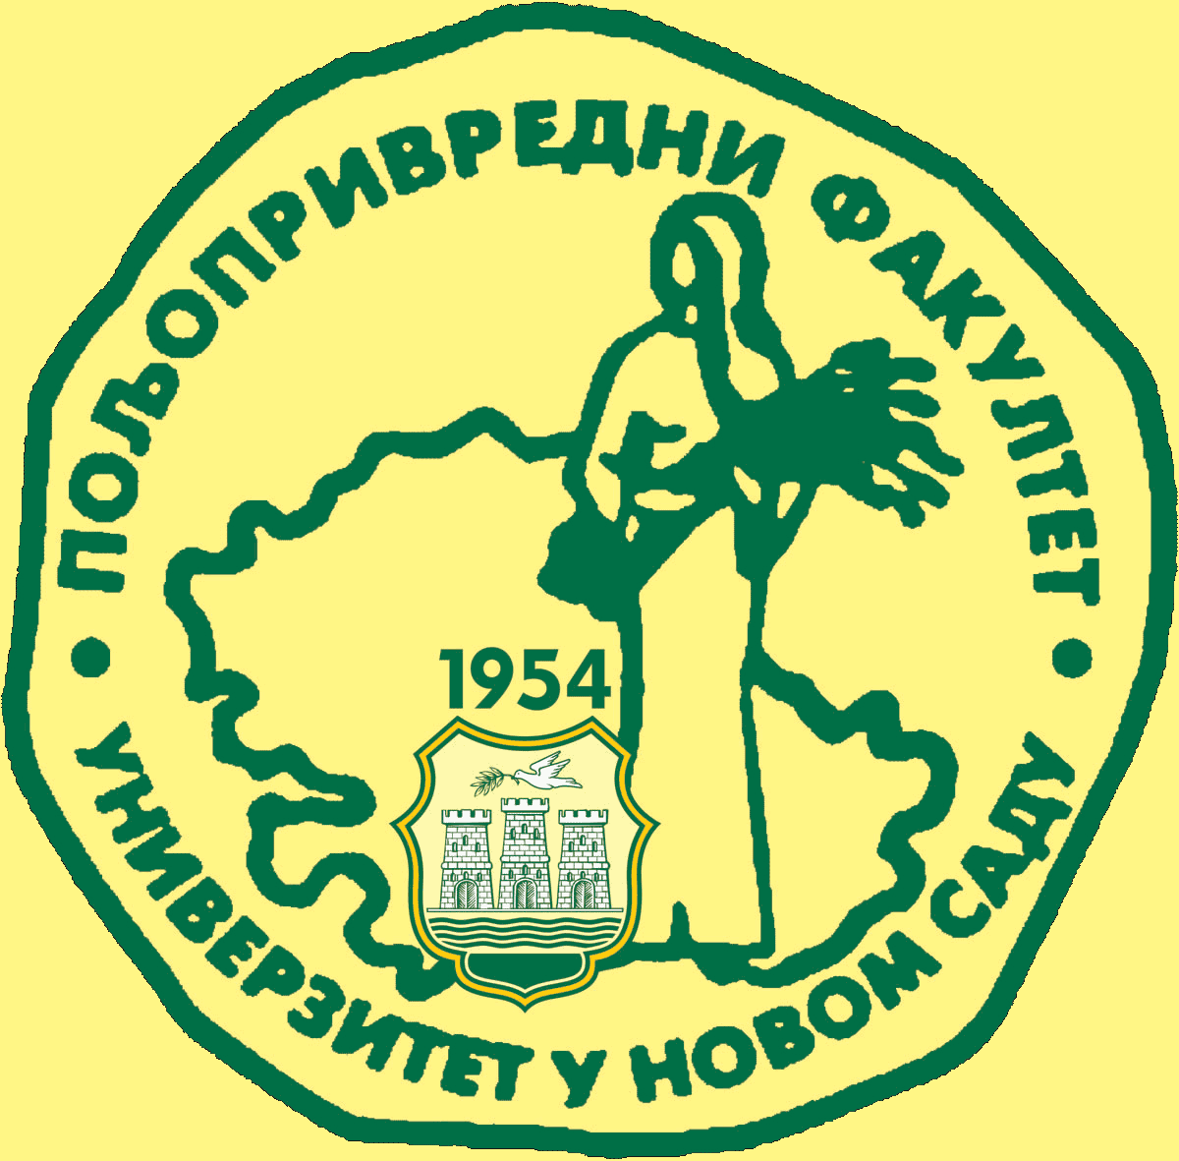
Study Programme Accreditation

MASTER ACADEMIC STUDIES - AGRICULTURAL WATER MANAGEMENT (LOLAqua)
Table 5.2 Course specification

