Course: |  | ON-FARM IRRIGATION AND DRAINAGE
Course id:
Number of ECTS: 6
Teacher: |  | Ruzica Stricevic, Enrique Playan, Nevenka Djurovic, Atila Bezdan
Course status |  | Mandatory
Number of active teaching classes (weekly)
Lectures:3 |  | Practical classes:3 |  |  | Other teaching types: |  | Study research work: |  | Other classes:
Precondition courses |  | None
- Educational goal
The topic will cover all elements needed for sustainable water management and needs for improvement, steps will be taken towards the implementation of the Water Framework Directive.
- Educational outcomes
Develop skills for the management of irrigation and drainage systems at the farm level. Familiarise with the basic scientific and technological tools commonly used to schedule irrigation, apply irrigation water on-farm, manage drainage systems and monitor water quality degradation in agricultural systems. Use a „learning by a case study“ approach.
- Course content
Theoretical lecturing
Irrigation: Surface, sprinkler and drip irrigation systems: morphology, design and evaluation; On-farm irrigation scheduling: networks of agro-meteorological weather stations, software applications, on-farm programming equipment. Collective irrigation networks: water conveyance networks (canals and pipelines), reservoirs, hydrants, open channel flow measurement, telemetry and remote control systems; Irrigation districts: nature, organization, water management activities, operation and maintenance, computer assisted management; Water quality assessment in irrigated projects: salinity, nitrates, phosphorus, impact of the EU water Framework Directive. Drainage: drainage networks, morphology, design and evaluation; on-farm drainage systems, water management activities, computer assisted management, operation and maintenance based on water cost recovery principles; Drainage water quality assessment, gaps in I&D management; organizing strategic change process – participatory approach, water user associations for drainage system management, legal frameworks; water boards.
Practical lecturing (Tutoring)
Exercise, learning by case study approach, semester project.
- Teaching methods
Lectures and exercises. Students will accomplish a semester project and present results in oral and in writing. The work counts for 60% of the final grade. The lectures are held in English. Retake exams may be oral only.
Knowledge evaluation (maximum 100 points)
Pre-examination obligations |  |  | Mandatory | Points |  | Final exam |  | Mandatory |  |  | Points
Assignments |  |  | Yes | 60 |  | Written and Oral |  | Yes |  |  | 40
Literature
Ord. | Author |  | Title |  |  | Publisher |  |  |  | Year
 | Skogerboe G. V., and Merkley G. P. |  | Irrigation maintenance and operations learning process |  |  | Highlands Ranch, Colorado, USA, Water Resources Publications, LLC, 358 p. |  |  |  | 1996
 | Vermillion D. and Sagardoy J.A. |  | Transfer of irrigation management services |  |  | FAO Irrigation and drainage papers No 58. |  |  |  | 1999
 | Snellen W.B. |  | Irrigation water management |  |  | Irrigation scheme operation and management. FAO. |  |  |  | 1996
 | Vlotman W.F., Rycroft D.W., and Smedema L.K. |  | Modern Land Drainage Planning, Design and Management of Agricultural Drainage Systems |  |  |  |  |  |  | 2004
 | Keller J., and Bliesner R. D. |  | Sprinkle and trickle irrigation |  |  | New York, NY, Van Nostrand Reinhold, 652 pp. |  |  |  | 1990
6. |  |  |  |  |  | Internet sources (articles, reports, presentations).
 | UNIVERSITY OF NOVI SAD  FACULTY OF AGRICULTURE 21000 NOVI SAD, TRG DOSITEJA OBRADOVIĆA 8 | 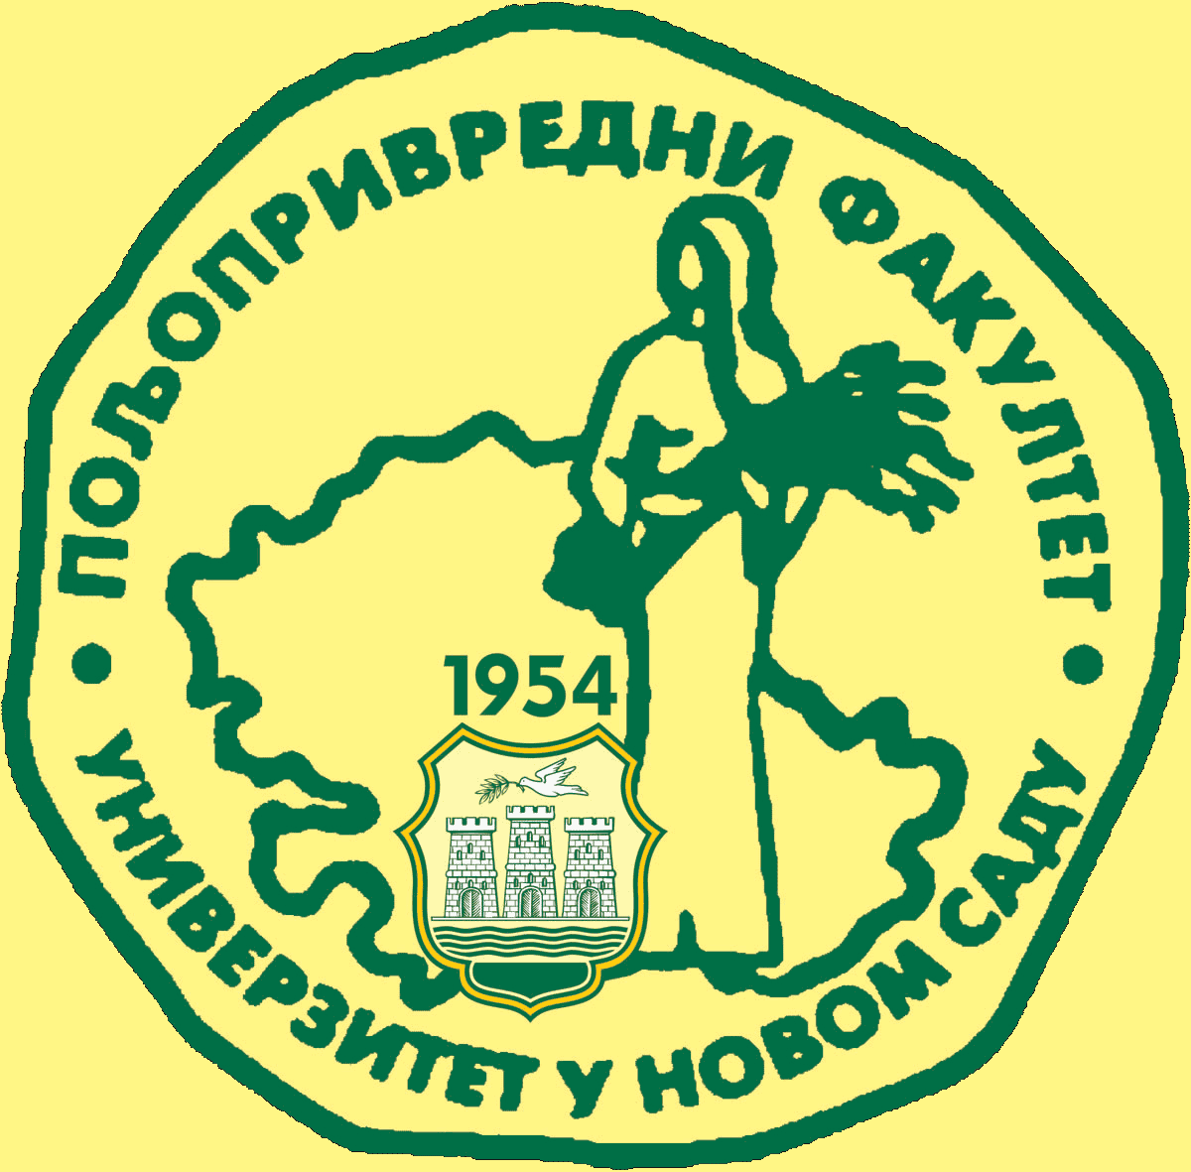
Study Programme Accreditation

MASTER ACADEMIC STUDIES - AGRICULTURAL WATER MANAGEMENT (LOLAqua)
Table 5.2 Course specification

