 | UNIVERSITY OF NOVI SAD  FACULTY OF AGRICULTURE 21000 NOVI SAD, TRG DOSITEJA OBRADOVIĆA 8 | 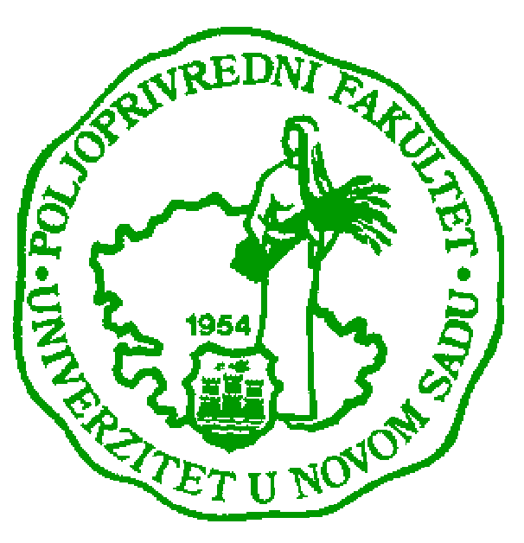
Study Programme Accreditation

UNDERGRADUATE AND MASTER ACADEMIC STUDIES
Table 9.1 Science, arts and professional qualifications
Name and last name: |  |  |  |  |  |  |  |  | Radovan B. Savić
Academic title: |  |  |  |  |  |  |  |  | Full Professor
Name of the institution where the teacher works full time and starting date: |  |  |  |  |  |  |  |  | University of Novi Sad, Faculty of Agriculture, 1. Oct.1985.
Scientific or art field:
Academic carieer
 |  |  |  |  | Year | Institution |  |  |  |  | Field
Academic title election: |  |  |  |  | 2013 | University of Novi Sad, Faculty of Agriculture |  |  |  |  | Water management
PhD thesis: |  |  |  |  | 2000 | University of Novi Sad, Faculty of Agriculture |  |  |  |  | Water management
Specialization:
Magister thesis |  |  |  |  | 1993 | University of Novi Sad, Faculty of Agriculture |  |  |  |  | Water management
Bachelor's thesis |  |  |  |  | 1984 | University of Novi Sad, Faculty of Agriculture |  |  |  |  | Water management
List of courses being held by the teacher in the accredited study programmes
 |  | ID | Course name |  |  |  |  | Study programme name, study type |  |  |  | Number of active teaching classes
1. |  |  | River engineering |  |  |  |  | Water management, Undergraduate |  |  |  | 4+2
2. |  |  | Erosion control |  |  |  |  | Organic agriculture, Undergraduate |  |  |  | 3+2
3. |  |  | Soil and water conservation |  |  |  |  | Water management, Master |  |  |  | 2+2
4. |  |  | Sediment management |  |  |  |  | Agricultural water management (LOLAqua), Master |  |  |  | 2+2
Representative refferences (minimum 5, not more than 10)
 | Savic R., Ondrasek G, Josimov-Dundjerski J. (2015) Heavy metals in agricultural landscapes as hazards to human and ecosystem health - a case study on zinc and cadmium in drainage channel sediments, Journal of the Science of Food and Agriculture, 95(3-2015), 466-470.
 | Savic R., Ondrasek G., Bezdan A., Letic Lj., Nikolic V. (2013): Fluvial deposition in groyne fields of the middle course of Danube river. Technical Gazette 20, 6(2013), 979-983.
 | Savic R., Belic A., Pantelic S. (2013): Comparative review of sediment properties from drainage canals. Polish Journal of Environmental Studies, 22(3), 849-859.
 | Savić R., Maksimović L., Cimpeanu S., Bucur D., Ondrašek G, Vasin J., Harja M., Milić S. (2013): Hazardous and harmful substances in sediments of the Jegricka stream, Journal of Food, Agriculture & Environment, 11(1): 1152-1156.
 | Savić R., Letić Lj., Benka P., Ondrašek G., Nikolić V. (2012): Spatial and Temporal Distribution of Potential Vulnerability to Wind Erosion Processes in Vojvodina, Agroknowledge journal, 13(2), 191-198..
Summary data for the teacher's scientific or art and professional activity:
Quotation total:
Total of SCI (SSCI) list papers: |  |  |  |  |  |  | 9
Current projects: |  |  |  |  |  |  | Domestic: |  |  | International:
Specialization

