Course: |  | Soil fertility and fertilization
Course id:3OOП3О12
Number of ECTS: 6
Teacher: |  | Prof.dr.Maja, S., Manojlović, MSc Klara Marijanušić
Course status |  | Mandatory
Number of active teaching classes (weekly)
Lectures: 3 |  | Practical classes: 2 |  |  |  |  | Other teaching types:/ |  | Study research work:/ |  | Other classes:/
Precondition courses |  | None
- Educational goal
The acquisition of basic knowledge of soil fertility and fertilizer application.
- Educational outcomes
A student who successfully completes this course will be qualified for further training through master's and PhD programs, as well as be able to apply the acquired knowledge in agricultural practice
- Course content
Theoretical instruction
Introduction. Soil fertility. Nitrogen in the soil. Phosphorus in the soil. Potassium in the soil. Other essential macroelements. Beneficial elements. Microelemets in the soil. Heavy metals in the soil.Soil properties and processes in relation to plant nutrition and fertilizer application. Fertilizers, the aim and division. Organic fertilizers. Commercial fertilizers. Soil conditioners. Properties and principles of fertilizers application. The control system of soil fertility and the use of fertilizers.
Practical instruction
Laboratory exercises: Soil resource and fertility. The control system of soil fertility and the use of fertilizers. Soil sampling. Determination of total and mineral nitrogen in soil. N-min method. Phosphorus in soil. Potassium in soil. Microelements in soil. Field experiment. Basic properties of fertilizers. The regulation of fertilizers and soil conditioners. Principles for determining the dose of fertilizer.
- Teaching methods
Lectures, Practice/ Practical classes, Consultations
Knowledge evaluation (maximum 100 points)
Pre-examination obligations |  |  |  | Mandatory |  | Points |  | Final exam (izabrati) |  | Mandatory |  | Points
Lecture attendance |  |  |  | Yes |  |  |  | Oral part of the exam |  | Yes |  | 30-70
Test |  |  |  | Ye |  | 30-60
Exercise attendance |  |  |  | Yes |  | 6-10
Term paper |  |  |  | No
Literature
Ord. | Author |  | Title |  |  |  |  |  | Publisher |  |  | Year
 | Maja Manojlovićd |  |  |  | Đubrenje u održivoj poljoprivredi |  |  |  | Poljoprivredni fakultet, Novi sad |  |  | 2008
 | Ubavić, M., Bogdanović, D. |  |  |  | Agrohemija |  |  |  | Poljoprivredni fakultet, Novi sad |  |  | 2001
 | Jakovljević, M., Pantović, M. |  |  |  | Hemija zemljišta i vode |  |  |  | Poljoprivredni fakultet, Zemun |  |  | 1991
 | Lampkin, N. H. |  |  |  | Organic Farming. Farming Press |  |  |  | Ipswich |  |  | 1994
 | Havlin J.L. et al., |  |  |  | Soil fertility and fertilizers |  |  |  | Pearson education, Inc. Upper Saddle River, New Jersey |  |  | 2005
 | Ubavić, M., Bogdanović, D. |  |  |  | Praktikum iz agrohemije |  |  |  | Poljoprivredi fakultet, Novi Sad |  |  | 1995
 | UNIVERSITY OF NOVI SAD  FACULTY OF AGRICULTURE 21000 NOVI SAD, TRG DOSITEJA OBRADOVIĆA 8 | 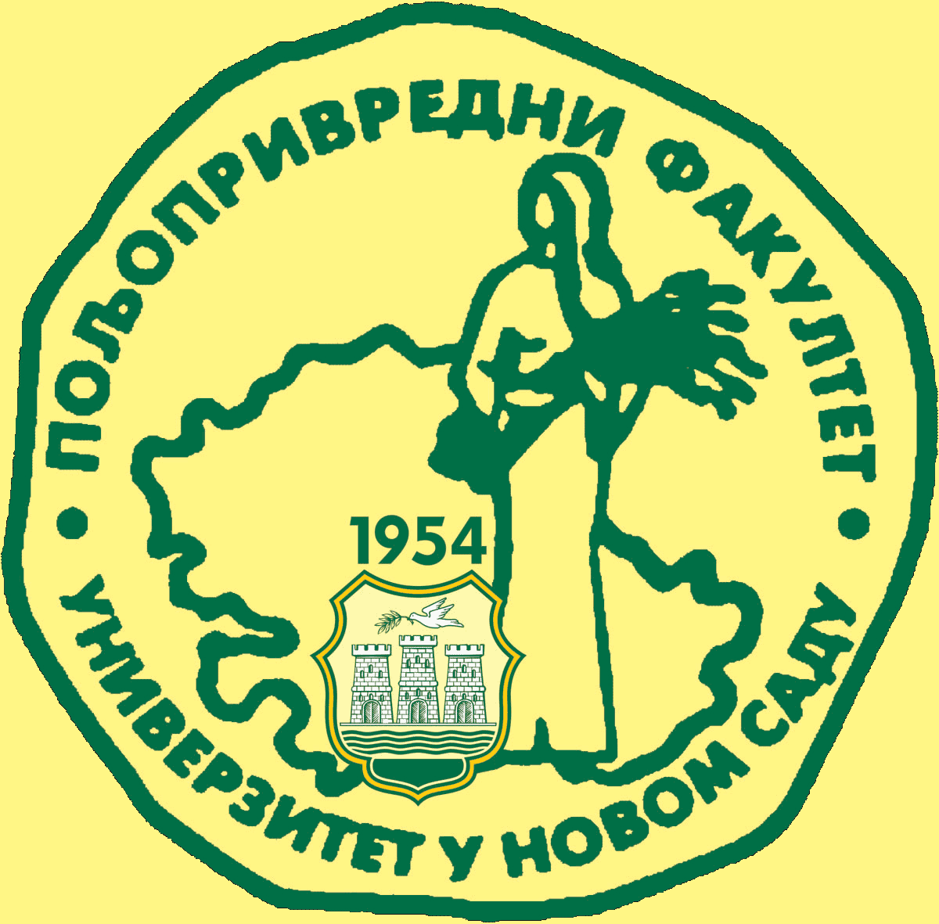
Study Programme Accreditation

BECHELOR ACADEMIC STUDIES: ORGANIC AGRICULTURE
Table 5.2 Course specification

