Course: |  | Diseases and pests in organic agriculture
Course id: 3OOP4O19
Number of ECTS:6
Teacher: |  | Ferenc F. Bagi, Pero M. Štrbac  Dragana B. Budakov, Aleksandra M. Konjević
Course status |  | Mandatory
Number of active teaching classes (weekly)
Lectures:  3 |  | Practical classes:  2 |  |  | Other teaching types: |  | Study research work: |  | Other classes:
Precondition courses: -Microbiology |  | None/
- Educational goal
Introducing the harmful pests and economically most important diseases in plant production, which provides the basis for their timely management or reduction of the population to tolerate level according to the principles of organic production.
- Educational outcomes
This course will provide the basis for recognizing the most important pests and diseases symptoms in organic plant production. Special attention will be addressed to their biology and ecology, as well as the degree of damage to the affected plants, which will enable timely and cost-effective management in accordance with good agricultural practice in the framework of organic production.
- Course content
Theory lessons Phytopathology: History of plant pathology, basic information on parasitism, pathogenesis, epidemiology, basic characteristics of plant pathogenic fungi, bacteria and viruses, general principles for control of plant diseases, biocontrol. The economic importance, distribution, symptoms, epidemiology and management of the most important diseases of cultivated plants in organic production. Entomology: Impact of polyphagous pest species on quantity and quality of agricultural products yield. Polyphagous pest species in field crops, cereals and arable crops, industrial plants, forage crops, vegetables, fruits and vineyards. Importance and distribution of pest species, biology and ecology of their development. Crop protection measures in organic production. Integrated pest management in organic production including administrative measures, cultural practice, mechanical measures and biological control.
Practical teaching: Exercises, Other modes of teaching, Study research work Phytopathology: General techniques in laboratory work with phytopathogenic microorganisms. Identification of pathogens, the detection of pathogens. Types of symptoms of plant diseases. Fundamentals of morphology and systematics of the causal agents of plant diseases, lifecycles. Entomology: Morphology of insects, use of keys for determination of live and preserved material, recognition of the most important pest species feeding symptoms of organic cultivated plants.
- Teaching methods
Lectures, Practical classes, Consultations
Knowledge evaluation (maximum 100 points)
Pre-examination obligations |  |  | Mandatory | Points |  | Final exam (izabrati) |  | Mandatory |  | Points
Colloquium Phytopathology |  |  | Yes | 15 |  | Oral part of the exam Phytopathology |  | Yes |  | 35
Colloquium Entomology |  |  | Yes | 15 |  | Oral part of the exam Entomology |  | Yes |  | 35
Literature
Ord. | Author |  | Title |  |  | Publisher |  |  |  | Year
 | Stojšin, V., Bagi, F., Balaž, F. |  | Plant pathology textbook- mycosis and pseudomycoses of field and vegetable crops (in Serbian) |  |  | Faculty of Agriculture Novi Sad |  |  |  | 2008
 | Balaž, F., Balaž, J., Tošić, M., Stojšin, V., Bagi, F. |  | Phytopathology. Diseases of crops and vegetables (in Serbian) |  |  | Faculty of Agriculture Novi Sad |  |  |  | 2010
 | Čamprag, D., Kereši, T., Štrbac, P. |  | Seed pests of field crops in fields and storagehouses. (in Serbian) |  |  | Novi Sad |  |  |  | 2001
 | Štrbac, P |  | Pests in field and vegetable crops (in Serbian) |  |  | Faculty of Agriculture Novi Sad |  |  |  | 2012
 | Štrbac, P., Čamprag, D. |  | Integrated pest management (Cultural Practices) and Pests in field crops (in Serbian). |  |  | Faculty of Agriculture Novi Sad |  |  |  | 2013
 | Ivanović M., Ivanović, D. |  | Plant mycosis and pseudomycoses (in Serbian) |  |  | Faculty of Agriculture Beograd |  |  |  | 2001
 | UNIVERSITY OF NOVI SAD  FACULTY OF AGRICULTURE 21000 NOVI SAD, TRG DOSITEJA OBRADOVIĆA 8 | 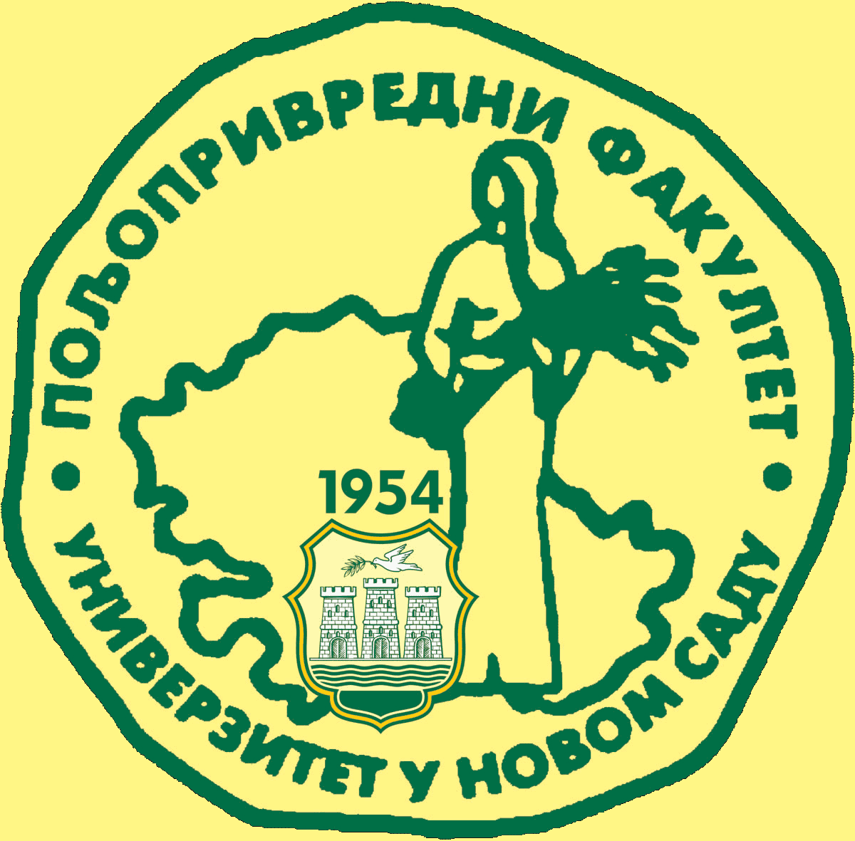
Study Programme Accreditation
BACHELOR STUDIES Organic Agriculture
Table 5.2 Course specification

