Course: |  | Diseases and pests of field crops
Course id: 3ORT6021
Number of ECTS:7
Teacher: |  | Vera B. Stojšin, Pero M. Štrbac  Dragana B. Budakov, Aleksandra M. Konjević
Course status |  | Mandatory
Number of active teaching classes (weekly)
Lectures:  4 |  | Practical classes:  3 |  |  | Other teaching types: |  | Study research work: |  | Other classes:
Precondition courses: -Microbiology |  | None/
- Educational goal
Introduction to economically most important diseases and pests of field and vegetable crops, as well as the possibilities of control measures.
- Educational outcomes
Students acquire basic knowledge of phytopathology and entomology in the area of field and vegetable production.
- Course content
Theory lessons
Phytopathology: Definition, importance and history of phytopathology, economically significant mycoses, bacterial diseases and viruses of field and vegetable crops. The appearance, distribution patterns, hosts, harmfulness, symptoms, characteristics of the pathogens, epidemiology, ecology, life cycle and management. Entomology: Basic knowledge of pests, including insects (Insecta), nematodes (phylum Nematoda), mites (Acarina), myriapods (Myriapoda, class Diplopoda), snails and slugs (Gastropoda, Mollusca), birds (Aves), rodents (Rodentia). Anatomy, biology, reproduction, classification, main pest species in field and vegetable crops. Main crop protection measures, including prophylaxis. Introduction to general entomology, morphology and anatomy of insects, development and reproduction, systematic. Applied entomology – main pest species in field and vegetable crops, as well as in green- and storage-houses. Introduction to Integrated Pest Management.
Practical teaching: Exercises, Other modes of teaching, Study research work
Phytopathology: Types of symptoms of diseases of field and vegetable crops. Fundamentals of morphology and systematics of causal agents of plant diseases, life cycles. Practical work on the plant material (microscopy) in order to determine the economically most important mycosis of field and vegetable crops. Entomology: Insect morphology and anatomy. Structure of insect body (individual examination of preserved insects). Drawings and schematic pictures. Insect development and metamorphosis. Types of insect metamorphosis, immature stages (nymphs and larvae), pupal stage and adults. Pest systematic and morphological characteristics of main insect orders, and families. Polyphagous pest species in field and vegetable crops.
- Teaching methods
Lectures, Practical classes, Consultations
Knowledge evaluation (maximum 100 points)
Pre-examination obligations |  |  | Mandatory | Points |  | Final exam (izabrati) |  | Mandatory |  | Points
Colloquium Phytopathology |  |  | Yes | 15 |  | Oral part of the exam Phytopathology |  | Yes |  | 35
Colloquium Entomology |  |  | Yes | 15 |  | Oral part of the exam Entomology |  | Yes |  | 35
Literature
Ord. | Author |  | Title |  |  | Publisher |  |  |  | Year
 | Stojšin, V., Bagi, F., Balaž, F. |  | Plant pathology textbook- mycosis and pseudomycoses of field and vegetable crops (in Serbian) |  |  | Faculty of Agriculture Novi Sad |  |  |  | 2008
 | Balaž, F., Balaž, J., Tošić, M., Stojšin, V., Bagi, F. |  | Phytopathology. Diseases of crops and vegetables (in Serbian) |  |  | Faculty of Agriculture Novi Sad |  |  |  | 2010
 | Štrbac, P.; Ćupina, A. |  | Entomology (Knowing, Sampling and Suppression of Insects) (in Serbian) |  |  | Novi Sad |  |  |  | 2000
 | Štrbac, P. |  | Pests in field and vegetable crops (in Serbian) |  |  | Novi Sad |  |  |  | 2005
 | Štrbac, P., Čamprag, D. |  | Integrated pest management (Cultural Practices) and Pests in field crops (in Serbian). |  |  | Faculty of Agriculture Novi Sad |  |  |  | 2013
 | UNIVERSITY OF NOVI SAD  FACULTY OF AGRICULTURE 21000 NOVI SAD, TRG DOSITEJA OBRADOVIĆA 8 | 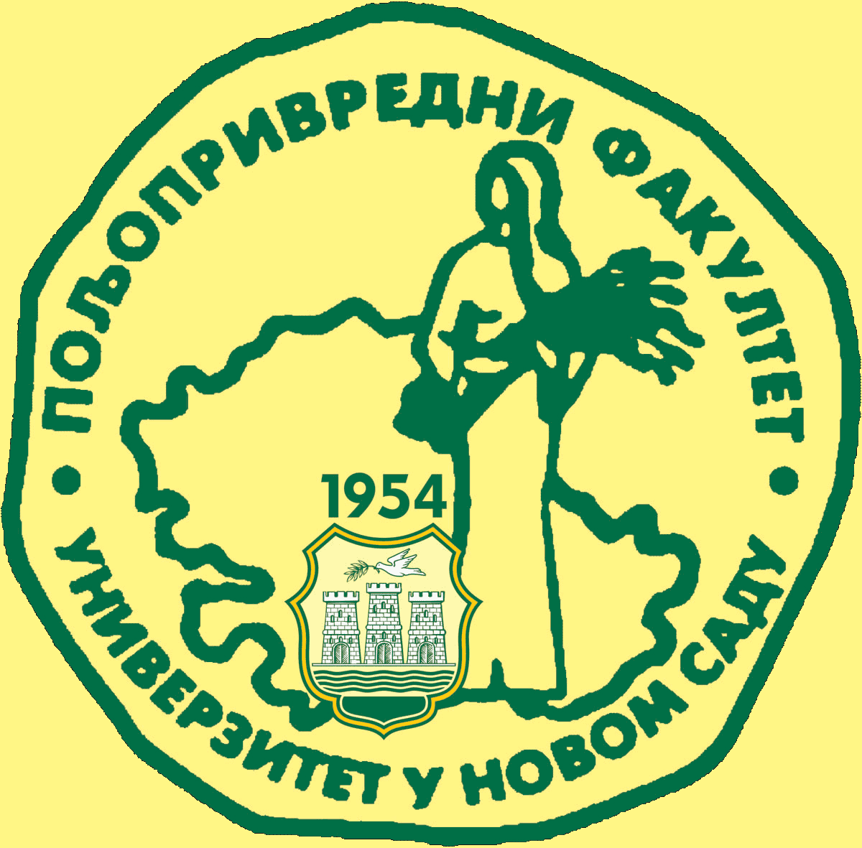
Study Programme Accreditation
BACHELOR STUDIES Field and vegetable crops
Table 5.2 Course specification

