 | UNIVERSITY OF NOVI SAD  FACULTY OF AGRICULTURE 21000 NOVI SAD, TRG DOSITEJA OBRADOVIĆA 8 | 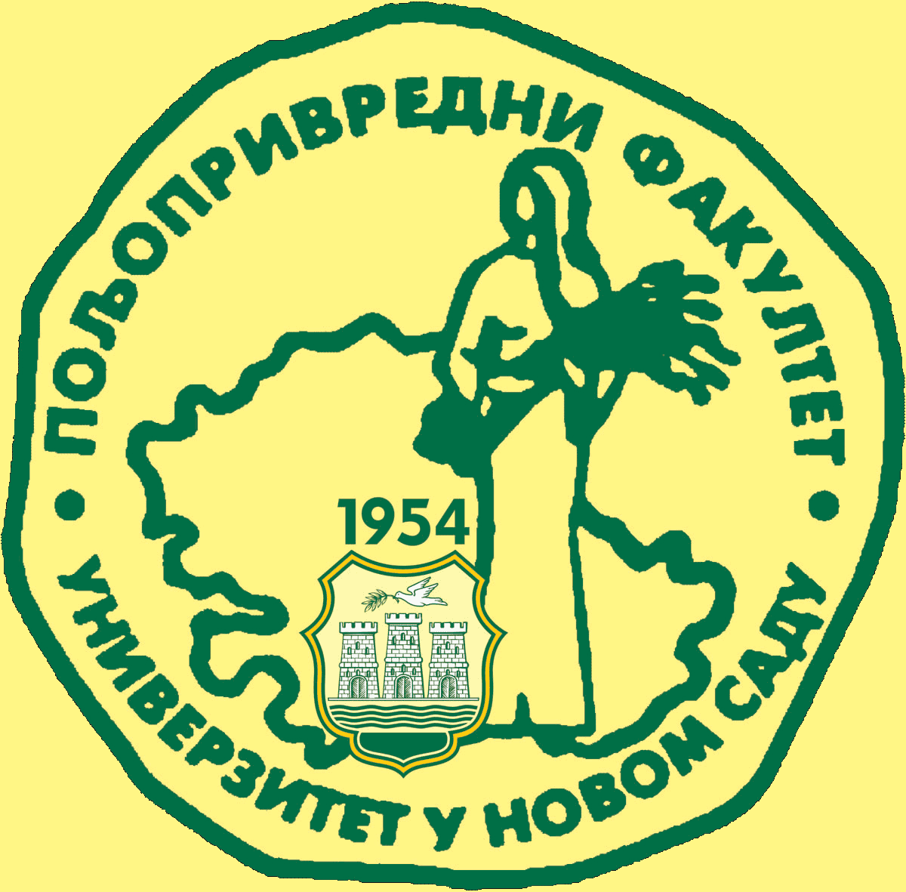
Study Programme Accreditation

UNDERGRADUATE ACADEMIC STUDIES
AGRICULTURAL TOURISM AND RURAL DEVELOPMENT
Table 5.2 Course specification
Course: |  | Еconomics of Tourism and Rural Tourism
Course id: 7ОАТ4О17
Number of ECTS: 6
Teacher: |  | Zoran M. Njegovan
Assistant: |  | Mirela Tomaš, Danica Glavaš Trbić
Course status |  | Mandatory
Number of active teaching classes (weekly)
Lectures: 3 |  | Tutorials: 2 |  |  | Other teaching types: |  | Study research work: |  | Other classes:
Precondition courses |  | None
1.Educational goals
The primary goal of the course is to introduce full-time students to the basic theory and practice of the economics of tourism and especially rural tourism as potential development drivers within globalised world and European processes, which can serve as a distinctive paradigm , and economic aspects of tourism and rural tourism as constituents of the economic development of the Republic of Serbia (within the historical, development, macroeconomic, industrial, systemic, resource, factor and sustainable context).
2.Educational outcomes
The programme of the course is designed for introducing students to the philosophy, theory and practice of economic aspects of the growth and development of tourism and rural tourism (sectoral approach), and depicting the interrelation and interconnection between the economics of tourism and rural tourism and the macroeconomic system as the environment in which tourism functions. Moreover, the course should provide students with sufficient knowledge, standard methodological and practical tools for analysing complex phenomena affecting tourism and rural tourism (its development and growth). They should also be able to design solutions favourable to tourism and rural tourism at both macro and micro levels of their manifestations.
3.Course content
Theoretical instruction:
Tourism economics – the concept, subject matter and status within social sciences; Economic theory of interdependence between economy and tourism; Relationship between tourism, rural tourism and economic development – historical overview and empirical tendencies of interdependence; World tourism development and the development of rural tourism as it significant constituent especially from the perspective of the global, regional and rural development; Competitiveness in international receptive and initiative tourism - tendencies and perspectives; Development policy of tourism and rural tourism as a constituent of tourism economics and the factors affecting its physiognomy in a country; Tourism aspects of economic integrations in the world and joint global appearance with special emphasis on the comparative overview of the EU tourism policy and its initial goals and final accomplishments; effects of global trends on future development of tourism and rural tourism, and the physiognomy of tourism offer within the liberalisation of world trade and the rules of the World Trade Organisation (WTO); Physiognomy and structure of the tourism policy in Serbia with special emphasis on: price system and policy, subsidies, loans and loan policy; tax system and social dimensions; ecological measures, and development and organisational state measures;
Basic determinants of tourism in our country – factors, structure and development.
Practical Instruction: Every unit is delivered by means of theoretical and practical instruction. At the end of a unit, there is a discussion in which students actively participate. Application tutorials are organised in several groups and entail the following activities: subject matter revision and presenting seminar papers.
4.Teaching methods
Lectures, discussions, consultations, tutorials, tests, seminar papers, presentations of individual and group papers.
Knowledge evaluation (maximum 100 points)
Pre-examination obligations |  |  | Mandatory | Points |  | Final exam |  | Mandatory |  | Points
Lecture attendance |  |  | Yes/No | 15 |  | Written exam |  | Yes/No |  | -
Tutorial attendance |  |  | Yes/No | - |  | Oral exam |  | Yes/No |  | 30
Tests |  |  | Yes/No | 40
Seminar paper |  |  | Yes/No | 15
Other |  |  | Yes/No
Literature
Ord. | Author |  | Title |  |  | Publisher |  |  |  | Year
1. | Unković, S., Zečević V., |  | Ekonomika turizma |  |  | Ekonomski fakultet, Beograd |  |  |  | 2007
2. | Airey, D., Tribe, J. |  | An International Handbook of Tourism Education |  |  | Elsevier, London |  |  |  | 2005
3. | Horvat Konsalting |  | Strategija razvoja turizma u Republici Srbiji do 2015. |  |  | Ekonomski fakultet |  |  |  | 2006
4. | Čačić K. |  | Menadžment turističkih agencija i organizacija putovanja |  |  | Beograd |  |  |  | 2003
5. | Unković, S. |  | Istraživanje turističkog tržišta i turistička propaganda |  |  | Beograd |  |  |  | 1997
6. | Biljen M. Bučar K. |  | Osnovi turističke geografije |  |  | Mikrorad, Zagreb |  |  |  | 2001

