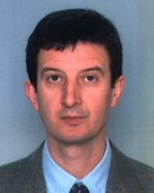
CONTACT
Prof. Dr. Branko Ćupina
Vice-Dean for Science and International Relations
Tel: +381 (0) 21 4853-224
e-mail: nauka@polj.uns.ac.rs

Dragana Krajinović, M.Sc.
International Relations Coordinator
Tel: +381 (0) 21 4853-212
e-mail: dkrajinovic@polj.uns.ac.rs

